**Experiment Procedure Documentation**

**Introduction**

This document captures the instructions to run the simulation.

**Instructions**

1. To run the experiment, simply run the exp3.html file by clicking on it and the experiment will open in the browser.

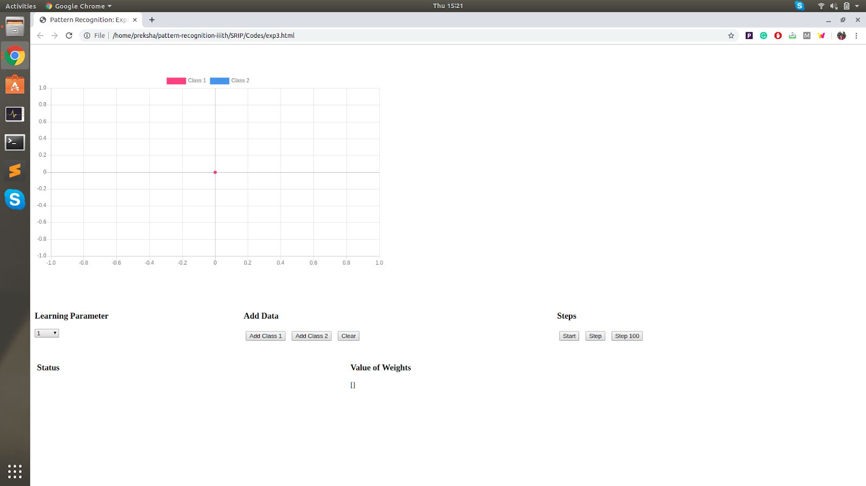

1. To run the experiment of perceptron, add the 2 classes. After clicking on the ‘Add Class 1’ button, this will appear. Add the x-axis and y-axis of the points you need to add for the class 1.

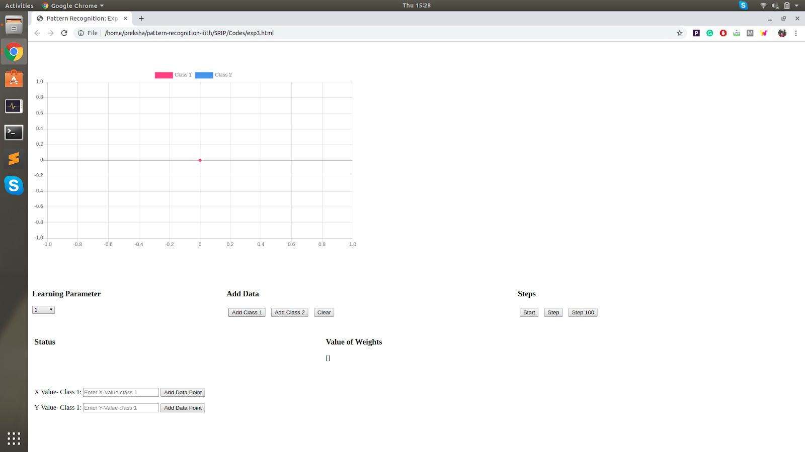

1. Similarly add data points for class 2 after clicking the ‘Add Class 2’ button and then adding the x-axis point and y-axis point.

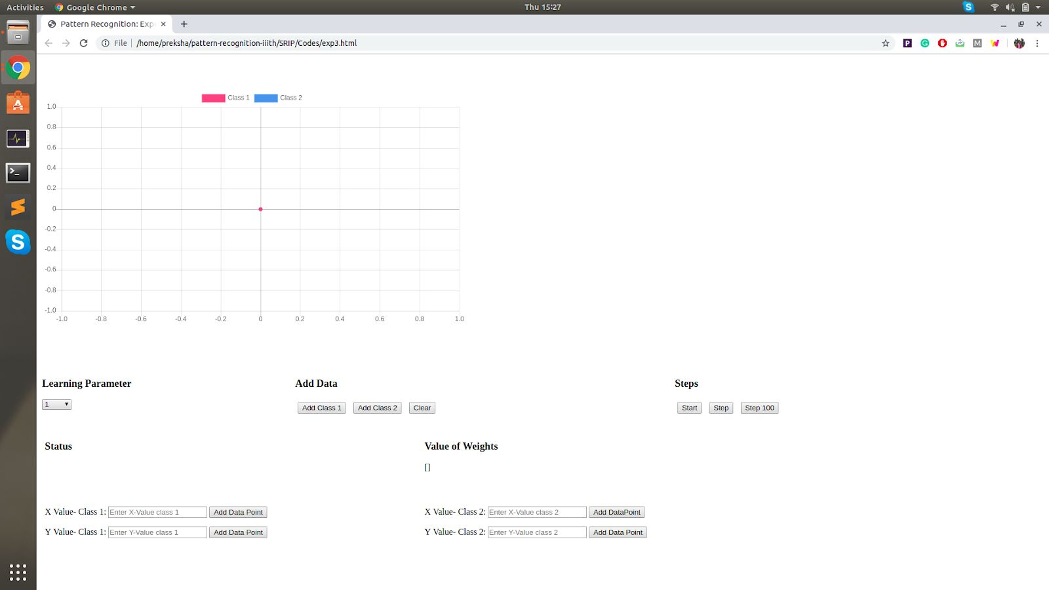

1. Select a learning parameter value from the drop down list under ‘Learning Parameter’.
2. After clicking on the ‘Start’ button, the perceptron algorithm will run for the given data points of the 2 classes and the perceptron line will be plotted on a new graph created.
3. The value of the final weights will be displayed under ‘Value of Weights’.
4. If you click on the ‘Step’ and ‘Step 100’ button, it will display the number on iterations taken to complete the algorithm.